Expressive Movement and Physical Model Animation Improvements Required of the Captain Scarlet Television Series
Sequence Time 7:55-8:10

Lindsay Grace
University of Illinois, Chicago
PhD Student

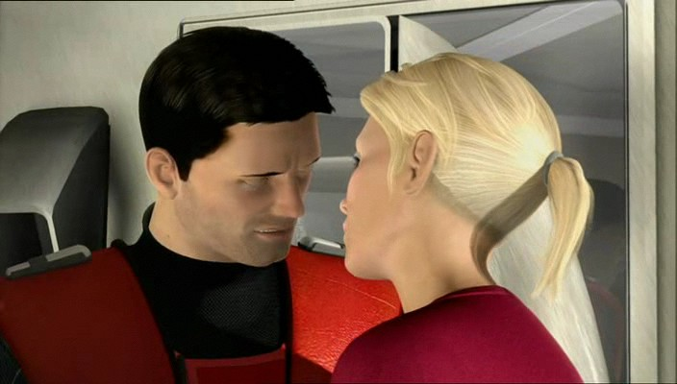

Overview and Abstract

Debuted in 2005, the original animated series, Gerry Anderson’s New Captain Scarlet, demonstrates the continued progress of computer-generated imagery (CGI) to produce fantastic images of fictional worlds. The techniques employed by the staff at Centurion are familiar, effective methods for animating worlds in the low budgets and short production cycles of the television animation world. While upon first glance the CGI is convincing, the attention to the natural physics of every day life are highly lacking. As with the animation of the 1960’s and 1970’s Anderson’s animation supplements broad-brush strokes for intimate details that convince an audience to believe in the fiction he has created. This is complimentary to Anderson’s original Supermarionation effect, which, while technically interesting, required suspension of disbelief to immerse the audience.

In this paper I have chosen to evaluate a single scene that exemplifies the need to allocate more resources toward the integration and animation of characters, props, and models in composited scenes. This paper serves to illuminate the successes and failure of two non-contiguous character animations sequences of 15 seconds length. The first is between 7:55 and 8:10, while the second, located at 11:30 to 11:45 serves only to emphasize the demonstrated in the first sequence. Both sequences are taken from Captain Scarlet Series 2, Episode two entitled Duel. I posit that a few technological and artistic production changes available in 2005 could have greatly enhanced the quality of the production without significantly increasing budget or time to production.

Introduction and Background

Why Critique Character Animation?

American and British audiences have historically emphasized the movements of characters in their evaluation of quality animation. However, the productions attention to character animation can be as plastic as his Supermarionated puppets. Foreshortened by a shallow script and overshadowed by the series’ traditionally fantastic vehicles, the characters are the visual element that requires the most attention.

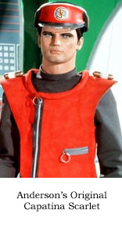
Unlike moving 20-ton vehicles across the lunar surface, or shuttling a jet-fueled motorbike through traffic, our experience with the movement of fabric, skin, and the human body are part of our everyday experience. It is these aspects that the critical mind recognizes most immediately as artificial. It is these elements that require the most detail, the most physical accuracy, and the attention of a cunning, creative artist. It is these details that inspire audiences to fear for the characters that face danger in the action sequences or wish death to the evil villains of a modern hero’s epic.

It is no small effort to convince audiences of a reality. Where in the 1960’s Anderson’s puppetry may have entertained young audiences, that same demographics’ point of reference is a comprehensive library of video games, computer enhanced live action film, and motion graphic embellished advertising. Today’s audience even has experience playing with low budget, simple to use character and environment animation technology like Daz Studio and Bryce. The notion of engaging the visual appetite of an audience through lightly veiled rigging has been tossed aside like an old toy. As audiences become better acquainted with the magic tricks of simulated reality, they become more critical of them. Audiences need more accuracy to real world physics if they are to believe the world an animator has constructed.

Ironically, the Ultramarionation technique is subject to many of the same limitations as the Supermarionation puppetry technique of Anderson’s past. Like the puppets of the original animation, characters lack subtle body expression, realistic hair and skin, and convincing interaction with objects. Beyond these shared challenges, CGI introduces palpable problems with physical movement distinct to a computer-generated world.

Analysis: Subtle Movement of Realistic Anatomy

Do You Know Body Language?

The Captain Scarlet series was animated using a combination of motion capture and key frame animation. If executed correctly motion capture encourages physical accuracy by providing a real world reference for the animation process. When a motion capture actor has appropriately executed their movements the animation should have the accurate joint offsets, join displacement and movement hierarchy. While it is the animator’s responsibility to refine the content of a motion capture scene, the reference data should provide adequate information for a realistic set of movements. Careful analysis of the scene indicates that the character movements are not accurate.

To their praise, the animators have done an excellent job of preserving some of the constant imperfect movements of the motion capture actors as they speak. Character 1 female, for example, moves her arm as she speaks and sways slightly. These subtle visual cues confirm the audience’s expectations of a realistic character. People move when they speak.

People also breathe, sigh and emote when they speak. As a typical artifact of conventional motion captures systems, the subtle movements of characters are absent. This is because most motion capture projects use motion capture to capture the focal visual cues. In an action sequence, these cues are typically character or prop movements such as firing a weapon or mounting a motorcycle. Motion capture may also be used to capture specific facial movements. In both of these motions capture activities; the focus is on the pantomimed, sometimes exaggerated movements that are easily discerned from a distance. However, in a conventional motion capture animation pipeline animators insert nuanced and embellished character movements to enhance the captured data.

As with most TV series, budgets and time to production were short for this series (insert reference). If the series had the resources of a major feature length film they could have hired the additional animators and developers to use and implement custom controls to accentuate movement of the chest and neck. However, modern production systems also offer predefined character model movements that provide some of the most traditional visual cues. XSI’s Softimage for example, provides a character animator suite of tools that maps routine chest movements associated with breathing to an anatomically correct model. The same enhancements are available through Alias and other commercial manufacturers.

At 8:01, the short falling of whole body expression is best indicated. While male character 1 demonstrates disappointment by the bend of his brow and the lowering of his head, his shoulders and posture remain unchanged. This sequence lacks the characteristic lowering of the shoulders and or stiffening of posture to indicate anger. This also would have been an excellent opportunity for a character animator to insert a sigh of frustration.
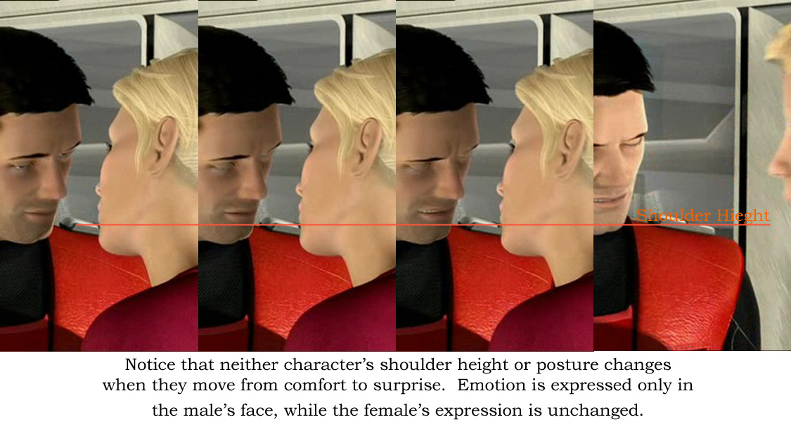

Why are you Acting Like a 5th Grader?

Real bodies communicate as they speak. The characters in Captain Scarlet lack the cooperative efforts of the upper body to emphasize what a character speaks. While much effort is spent moving eyes, eyebrows, and mouths, little is spent articulating expression through the whole body. Live action actors who provide performances equal to these virtual actors would be harassed for not being in their bodies. The performances are again 1 dimensional, relying largely on the first order of communication, but ignoring secondary communication in the hands, shoulders, and posture. These characters are essentially rigid bodies from the clavicle to the sacrum. Some might say, their movements are like middle schoolers on the school stage – rigid, pantomimed, an unemotional.
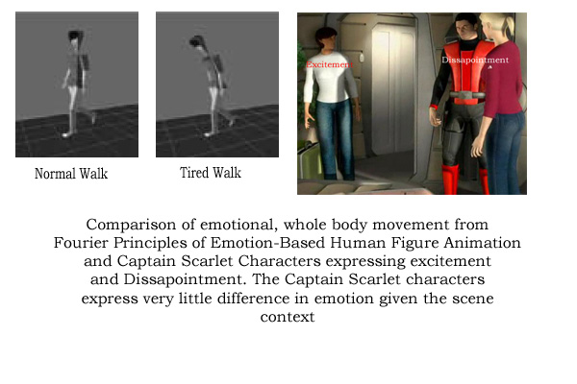
If you compare the expressions in the figure to the left with the Captain Scarlet model, the difference in posture is probably the most indicative physical element. While it may be true that some of this posturing is effected by the motion capture process itself, the animators have license to produce these changes through key frames. If for example, a character must express disappointment, the animator can key a movement from an upright posture, to a slouch while keying the facial expressions.

Several researchers have worked toward trying to indicate emotion in full character motion. Chi et al even provide a systematic approach to called the EMOTE model that was used to render real time animations effected by effort and shape parameters. Their research does an excellent job emphasizing the “important role torso plays in gesture and in the depiction of a convincing character”

If Only We Could Breath

The pace of a characters breathing communicates the characters emotional state. Although there are several moments where chest movements are inserted, most of them do not punctuate the characters emotional state. In the aforementioned scene, for example, a sigh from the romantic couple would punctuate their frustration with subtle, whole body communication.

One approach to enhancing the accuracy of the production teams standard 50-60 sensor animation techniques is to shoot the same scene with repositioned sensors based on camera distance. Instead of recording the movements of the entire body, a second motion capture session could be conducted with the same number of sensors mapped to the upper half of the body. Since the disparity between real world movement and animation movement is more apparent in close to mid shots, there is need for higher fidelity motion capture at this camera distance. The playback of a scene could be made more accurate by using more sensors over a smaller surface area. This simple change requires no new software, only a change in scheduling and management of the animation pipeline. The concept is to refocus the important visual cues based on the camera’s distance, as animators already do. In a close up, for example, there is information about the location of the character’s knees, yet when the scene is rendered that information will be discarded. It would be better use of computing resources to record only the items specified by the shot plan.

Analysis: World Physics and Implied Weight

Why are we Always Walking on the Moon?

The characters move with a weightlessness characteristic of computer-generated animation. The pace and cadence of their movements, whether in a high speed helicopter, or a city street remains the same. It is a smooth and tranquil movement that rides along the gentle rails of mathematical expressions. As with much CGI, the effort to correct the imperfections of translating the analogue world of everyday experience through the clean lines of the digital world results in a watery netherworld of geometrically, trigonometrically correct translations and rotations. Like something from a Science Fiction film, the characters simply lose their life to the formulas that govern them.

Don’t Hurry; the Math Will Get Us There

In the selected scene, the characters move at the same cadence. Whether it is to move toward a much desired kiss or to exclaim a clever quip, the characters movements are managed by formulas that calculate rates of movement and fit them into an ideal frames per second. The result is an artificially fluid movement; characters don’t shake, they have no weight to their own bodies, and lack momentum. In the selected scene, when two characters are surprised by a third, the inertia of swift change is drowned by the computing of perfect curves meant to bring the arms back down to an idle position. In the natural world surprise is communicated through the whole body and by quick, imperfect motions - a hand opens wider than is comfortable, the abdomen tenses, the body prepares to react. However in this scene, hands drop gracefully, and the upper body wavers as it always does.

To correct for this problem animators should have embellished character movements more finely. In this case, much of the motion capture data seems accurate, if not overly smoothed. Assuming that the motion capture actors performed well, the performances could benefit substantially from the hand of a skilled animator.

Although released the same year production of the Captain Scarlet series would have started, the work of Pullen and Bregler on Motion Capture Assisted Animation would have helped to provide more natural movements. There method of texturizing mocap data speaks to the need for animators to blend motion provided through observation with an artist’s touch.

Why Are We Always Walking on the Moon? Where did all the Mass Go?

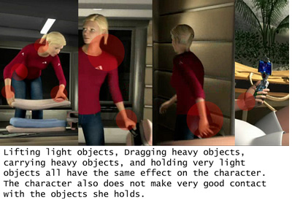
Through the entire animation, there is an apparent lack of physical weight. Not only do the characters seem to lack weight in their own bodies, but the props with which they interact all carry the same weight. Whether it is a large machine gun, a pistol or a heavy suitcase, the item characters carry, push or pull all produce minimal to no strain on the character.

As the scene ends and the characters carry their recently packed suitcases, their wrists do not bend under the strain. The characters extend their arms instead of bringing the baggage close to their bodies. When the suitcase is picked up, the arm does not give as the muscle tenses to collect it.

Since it is impractical to suggest collision based rendering, or physics engine for such simple needs, the production team should rely once again on the natural hand of an animator. Even without the opportunity to model underlying bones and muscles, the key frame can be tweened to imply resistance to objects. Animators can for example provide a delay between collecting an object and moving an object. They can bring an arm down when items like a phone are collected, instead of providing a straight, unaffected path to from the original objects location to it’s goal location.

Programmatically the applications used to animate could be enhanced by adding virtual gravity as executed in many video games. A constant force could effect character movements down on the Y-axis. The simple code is computational inexpensive, and might encourage animators to manage movements more carefully, as arms would descend and items would fall when pulled from bed.

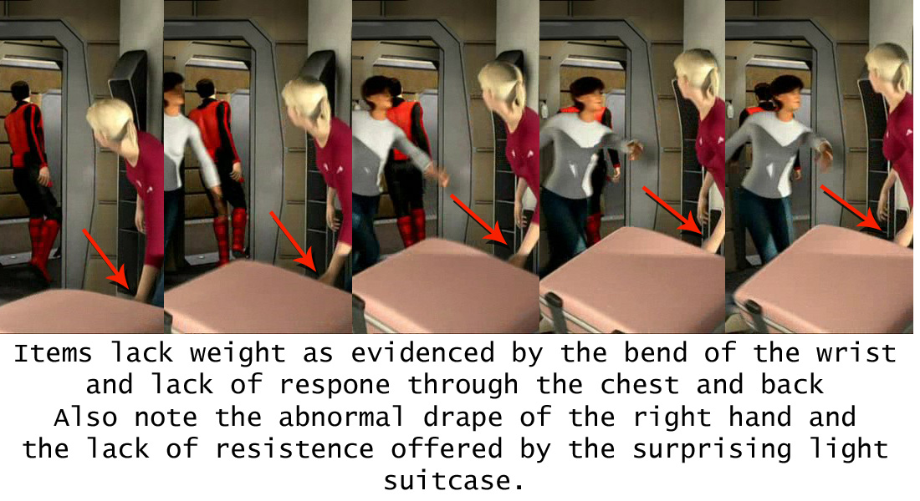

Analysis: Movement of Hair, Skin, and Clothing

Why Isn’t My Hair Moving

The modeling and animation of hair is an ongoing challenge for many animation teams. The reasons realistic hair and skin are so important to an audience is that they provide situational cues. If it is windy, hair blows. If it cold, the skin is ruddy. If it is hot, we sweat. If we are nervous, tired or excited the dermal layers of the human body indicate it. As with many fast animation techniques, the characters in this series are made plastic through the simplicity of their skin and hair. These characters have arguably more in common with _______ toys than with human beings.

The research of Ming et al. and Guang indicate some cost effective solutions for the accurate modeling of hair. Some hair systems are breeds of particle systems, which were sorely needed in scenes outside this discussion.

The most problematic movement of hair is demonstrated in female character 1’s ponytail. It moves as though it were a single rigid body whose base is mounted on a pivot. It swings, but the hair does not separate. It is more subtlety a problem for female character 2, as her hair is an actual rigid body that does not move. Short term, low budget solutions for this problem in interactive and cinematic animation include remodeling the character with a helmet or other items that prevents audiences from seeing the hair at all.

My One Complexion is Perfect

Skin is multiple layers. While the average person does not notice these individual layers when speaking to another person, the way each of those layers interacts with the environment is apparent to them. When a person turns red, it is clear the outer layers of the skin are not turning red, but that something behind the skin is turning read. When a person is worried, it is clear that their skin is not changing, but it being changed by something behind it. The characters in this series lack that fine differentiation. Real skin deforms based on the interaction of more than one layer.
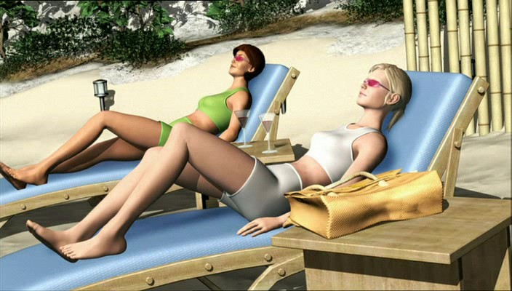
Save for the anonymous antagonist at the start of the episode, Captain scarlet characters are one dimensional in this respect. They lack an inherent or implied sub-dermal layer comprised of more skin, muscle and skeleton. This lack of a multi-layer model is so prevalent that at times the characters actually bend in artificial, elastic ways. Careful study indicates an abnormal curvature of the ankle while the women are sitting in the lounge chairs. It seems as though the joint have more range of motion than the average person does. Oppositely, there are no deformations of the skin when the women rise from the chairs. Visually it is implied that the skin is neither tight, nor loose. Instead, the hollow, thin layer surrounds a loosely articulated puppet. In short, its programmatically modeled structure is as apparent as the Anderson’s original models.

If time permitted and budget permitted, the production team could benefit from the work of Park and James. Multilayered skeletal models and accurate skinning would help the production, but their computational and budget expenses probably exceed this production’s limits. Careful examination problems in toes that don’t curl when the women move for example.

Skeletal modeling systems also would not solve the problem of the painted surfaces of the characters’ clothes and eyebrows. While, for example, the women’s sun bathing outfits imply clothing by the shape of the geometry, they do not deform adequately. Even the tightest Lycra bathing suit deforms differently than the body under it. It suggests that these objects do not have the proper geometry to bend and twist with their own physics. For cloth modeling I would suggest a review of the Baraff and Witkin. Siggraph paper on Large Steps in Cloth Simulation. Although nearly 8 years old, the papers approach is computationally efficient which makes it appropriate for this level of animation.

The animators of the popular Shrek feature film of 2001 employed an approach that might have solved the problem of artificially textured skin. Using the fundamentals of oil painting, they combined multiple textural layers to emulate the skin. An outer layer for example, would be a largely opaque, slightly reflective texture that provides the sense of oils on the skin. The second layer demonstrates substance with color that is more diffuse and lower secular and emissive values. The third layer would employ deeper color, and can be manipulated dynamically to emphasize states like anger (more red) or fear (more white). This technique could theoretically help add realism by giving lighting calculations more diverse normals from which to calculate conditions. A shirt for example might have a shiny base, but a rough layer of warn fibers that filter the refracted light.
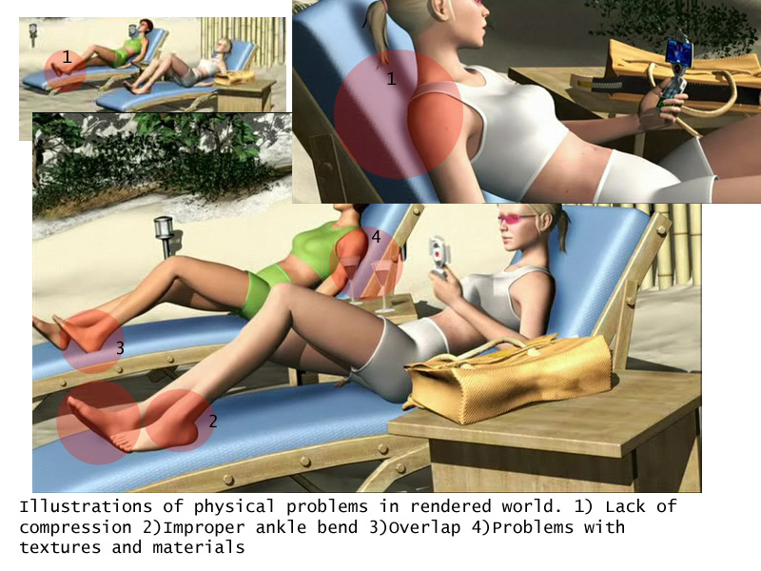

Same Old Problems: New World

Deadlines: The Biggest Enemy of All

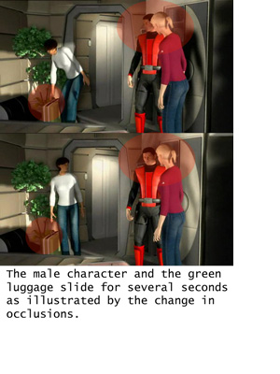
Just as traditional animators agreed to short fallings in the final product to meet deadlines, existing CGI animators produce, and publish their mistakes in the name of deadlines. The most egregious is the sliding that occurs in this scene. Likely a remnant of improper initial blocking, a critical eye will notice that a suitcase slides across the floor after it is placed. In compliment, the male character also slides. It would normally be conceivable that this is the result of field of view change. However, reference objects in the scene, such as a table or other characters indicate that this is not the case. It is more likely that these items were moved to prevent them from being occluded, keep them from being clipped, or prevent them from overlapping when composited.

To alleviate this problem, the simplest solution is to move the camera toward the scene so that this sliding occurs off camera. The production team likely attempted this, as the camera shifts, somewhat artificially to a near canted angle of the intruding female character 2.

If that is not reasonable to move the camera, then it might be reasonable to obscure the sliding element with some scene element in the foreground. Both of these techniques have been used in cell animation when productions are tight (show example if you can find one). The solutions are reasonable when there not enough time to re-render the entire scene.

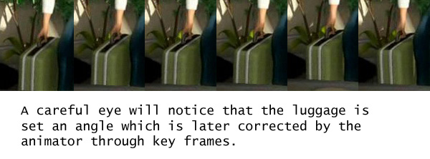

Issues I ran out of Space to Discuss:
The following are a few bullet pointed items worth mentioning, but the 2500 page limit prevents me from discussion in depth:

- Shadows change: multiple light sources seem to create varying size shadows that sometimes project in the wrong direction.

- Shadow placement wrong on phone and leg (11:46) – shadow on leg not on thigh.

- Eyes don’t move behind the eyelids

- No muscle flex when she moves herself up the chair (11:46)

- 2nd girl is going through her mat (11:46)
- Mat does not deform (11:46)

- 11:39 re-rendered as different scene and later edited in – different light source, allows them to render more polygons in less time (tight shot), but shadows displaced to right instead of left

- 8:02 – Paul slides away, as the background is locked (same as suitcase)

Conclusion

While the Captain Scarlet series does an excellent job of demonstrating the vast improvements the art of animation has accomplished, it is clear that many of the old challenges continue to exist. Similar to the Supermarionated puppets of Anderson’s past, the new Captain Scarlet CGI lacks accurate human movement and convincing world physics. These short fallings are best illustrated by the analysis of hair, skin, clothing, total character movements, and the interaction of prop and character.

To preserve clarity the characters in this series are identified as female character 1, female character 2 and male character 1. These are destiny, the blah, and blank respectively.
http://en.wikipedia.org/wiki/Gerry_Anderson's_New_Captain_Scarlet
http://www.artie.com/business/demographics_files/demographics.htm
http://www.fpsmagazine.com/blog/2006/10/oiaf-2006-television-animation.php
The Effects of Electronic Media on Children Ages Zero to Six: A History of Research. 2005. http://www.kff.org/entmedia/upload/The-Effects-of-Electronic-Media-on-Children-Ages-Zero-to-Six-A-History-of-Research-Issue-Brief.pdf
Tara Dilullo, Captain Scarlet from Puppets to Pixels. VFX World. 2005 http://www.vfxworld.com/?sa=adv&code=319b255d&atype=articles&id=2618
A Practical Approach to Motion Capture, Siggraph Online, http://www.siggraph.org/education/materials/HyperGraph/animation/character_animation/motion_capture/motion_optical.htm#Acclaim's%20System%20approach
Softimage|XSI 6, http://www.softimage.com/
CHI, D., COSTA, M., ZHAO, L., AND BADLER, N. 2000. The Emote model for effort and shape. proc. SIGGRAPH 2000, 173– 182. http://delivery.acm.org/10.1145/360000/352172/p173-chi.pdf?key1=352172&key2=2714095611&coll=GUIDE&dl=portal,ACM&CFID=11111111&CFTOKEN=2222222
MIT Communications Forum, http://web.mit.edu/comm-forum/papers/furniss.html
K. Pullen and C. Bregler. Motion capture assisted animation: Texturing and synthesis. In Proceedings of ACM SIGGRAPH 02, 2002. http://citeseer.ist.psu.edu/article/pullen02motion.html
Ming et al., Generation of 3D hair model from 2D image using image processing. In the International Society of Optical Engineering. p. 303-311, 1996 http://adsabs.harvard.edu/abs/1996SPIE.2847..303M
A method of human short hair modeling and real time animation in Computer Graphics and Applications, 2002. Proceedings.http://ieeexplore.ieee.org/xpl/freeabs_all.jsp?arnumber=1167891
Sang Il Park and Jessica K. Hodgins. Capturing and Animating Skin Deformation in Human Motion. ACM Transaction on Graphics (SIGGRAPH 2006),25(3),pp 881-889,July 2006. http://graphics.cs.cmu.edu/projects/muscle/
James and Twigg, 2005, http://www.ri.cmu.edu/pub_files/pub4/james_doug_2005_1/james_doug_2005_1.pdf
D. Baraff and A. P. Witkin. Large Steps in Cloth Simulation. In Proceedings of SIGGRAPH 98, Computer Graphics Proceedings, Annual Conference Series, pages 43–54, July 1998. http://ai.stanford.edu/~latombe/cs99k/2000/cloth.pdf
Shrek, Dir. Andrew Adamson and Vicky Jenson, Dreamworks SKG, 2001 Title of movie. Director (abbreviated as Dir.). Distributor, year of release. Additional References (uncited): http://www.cs.berkeley.edu/~daf/games/webpage/motionpapers/pullen02motion.pdf UNUMA, M., ANJYO, K., AND TEKEUCHI, R. 1995. Fourier principles for emotion-based human £gure animation. proc. SIGGRAPH 1995, 91–96. http://citeseer.ist.psu.edu/unuma95fourier.html Mahdi Astenah, http://72.14.203.104/search?q=cache:jXudjqN2DGQJ:mahdi.cheraghchi.info/talks/MAYA.ppt+shrek+animation+technique+overview&hl=en&gl=us&ct=clnk&cd=11&client=firefox-a URLs: Gerry Anderson fan site: http://www.fanderson.org.uk/epguides/ncseg1.html Internet Movie Database: http://www.imdb.com/title/tt0408377/

